3. AI Analysis Engine (Industry-Level Detail)
The AI Analysis Engine forms the core innovative component of Project 1, using a Vision Transformer (ViT) to process anonymised medical images and highlight areas of potential clinical interest. This supports (but does not replace) clinician review by generating visual overlays (heatmaps, attention maps, or bounding boxes) that indicate regions the model attends to. Design aligns with MHRA Good Machine Learning Practice (GMLP) principles: transparency, explainability, and human-in-the-loop oversight.
Implementation occurs in /models/ and /backend/ai_engine/ using PyTorch and Hugging Face Transformers for reproducibility, efficiency, and access to pre-trained weights.
Key Implementation Details
- Model Choice: Vision Transformer (e.g., ViT-B/16 or ViT-L/16) – selected for strong performance on medical imaging tasks with fewer inductive biases than CNNs.
- Pre-trained Base: Use Hugging Face hub models (e.g., google/vit-base-patch16-224-in21k) fine-tuned on public datasets.
- Fine-Tuning Examples:
  - Chest X-rays: CheXpert (Stanford), ChestX-ray14 (NIH), or MIMIC-CXR.
  - Pathology: PatchCamelyon (PCam) or public TCIA datasets.
  - Multi-task fine-tuning for classification + localization (weakly supervised).
- Inference Pipeline:
  - Input: Preprocessed image tensor (224x224 or 384x384, normalized per ImageNet stats).
  - Code framework: PyTorch Lightning or native Torch for training/inference scripts.
  - Output: Class probabilities + explainability visualizations.
- Explainability Features (Critical for Clinical Trust):
  - Attention Rollout/Maps: Native Transformer attention visualization (rollout across layers).
  - Grad-CAM / Adapted for ViT: Patch-level gradients or transformer-specific methods (e.g., ViT-Explanations).
  - Overlays: Heatmaps superimposed on original image for clinician dashboard.
Industry-Level Example Diagrams and Visuals
Figure 20: Standard Vision Transformer (ViT) architecture for medical image classification (Core patch embedding and transformer encoder structure.)
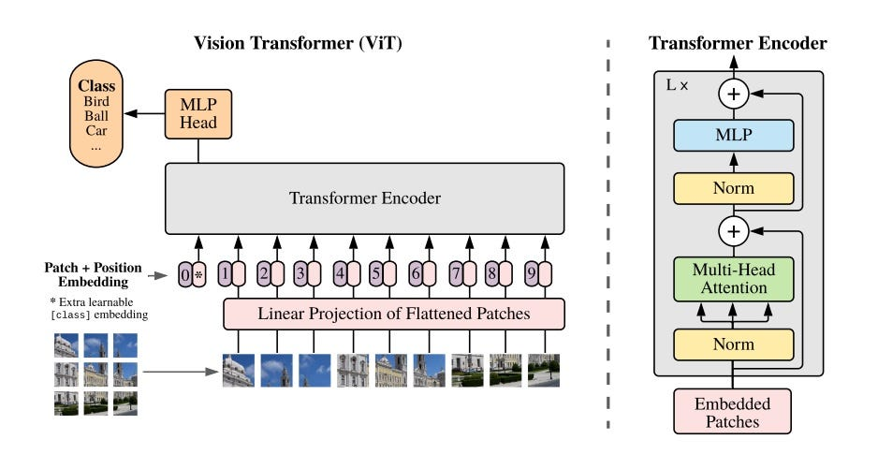
medium.com
Vision Transformer for classification on medical images. Practical ...
Suggested filename: fig20-vit-medical-classification.pdf
Figure 21: Detailed main architecture of the Vision Transformer (ViT) (Classic reference diagram showing patch + position embeddings.)
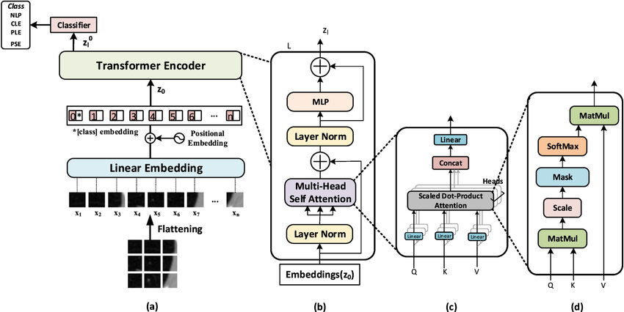
researchgate.net
The vision transformer architecture. (a) The main architecture of ...
Suggested filename: fig21-standard-vit-architecture.pdf
Figure 22: Advanced Vision Transformer for automatic medical image segmentation (Shows adaptations for dense prediction tasks.)
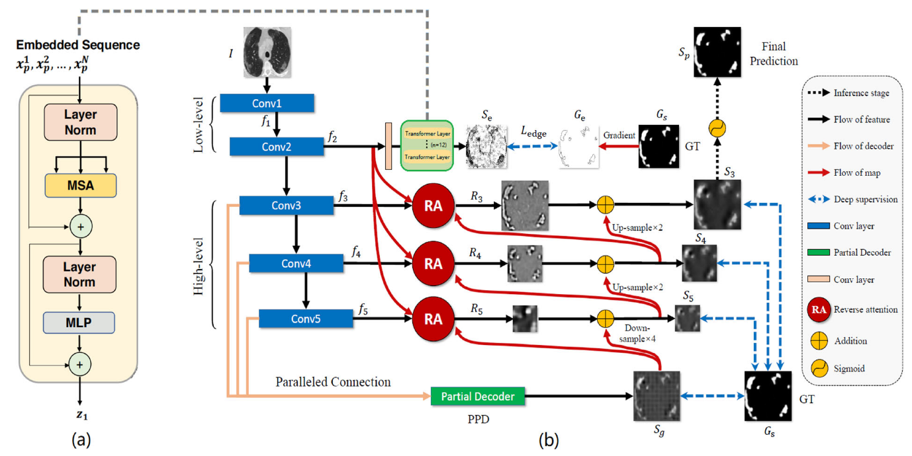
mdpi.com
Automatic Medical Image Segmentation with Vision Transformer
Suggested filename: fig22-vit-segmentation-medical.pdf
Figure 23: Self-evolving Vision Transformer architecture for chest X-ray diagnosis (Practical medical-specific ViT pipeline.)
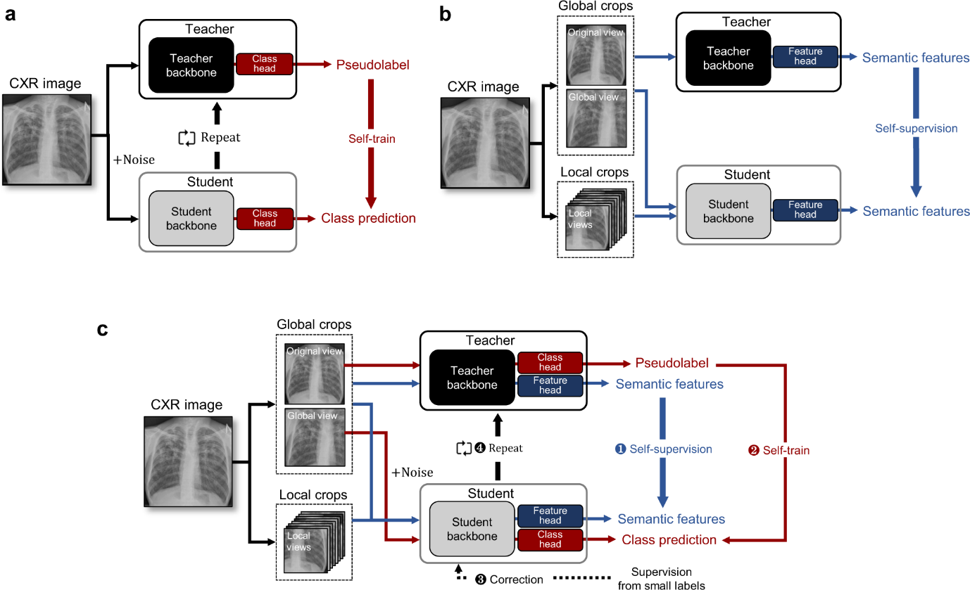
nature.com
Self-evolving vision transformer for chest X-ray diagnosis through ...
Suggested filename: fig23-self-evolving-vit-chestxray.pdf
Figure 24: Grad-CAM heatmaps overlaid on chest X-ray for pneumonia detection (Example of highlighting areas of interest.)
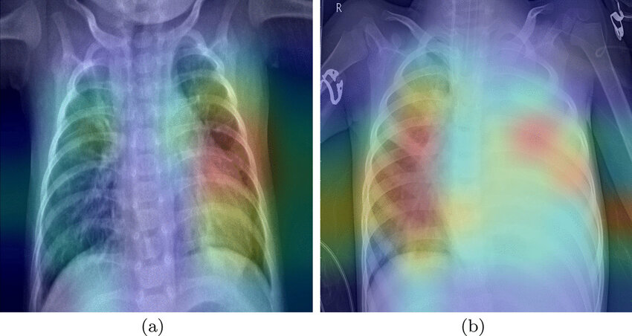
researchgate.net
Grad-CAM heatmaps for pneumonia CRX images | Download Scientific ...
Suggested filename: fig24-gradcam-pneumonia-chestxray.pdf
Figure 25: Original chest X-ray with corresponding Grad-CAM heatmap (Direct before/after comparison for explainability.)
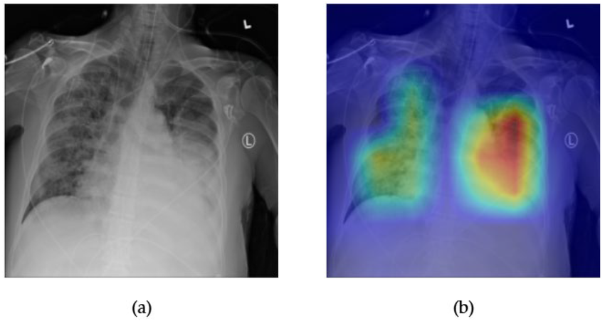
researchgate.net
Comparison between the original chest X-ray and its Grad-CAM ...
Suggested filename: fig25-gradcam-comparison-chestxray.pdf
Figure 26: Attention-based saliency maps from Vision Transformer on medical images (Transformer-native explainability output.)

pubs.rsna.org
Attention-based Saliency Maps Improve Interpretability of ...
Suggested filename: fig26-attention-saliency-vit.pdf
Figure 27: Fine-tuning pipeline for Vision Transformer on biomedical imaging datasets (End-to-end training workflow reference.)
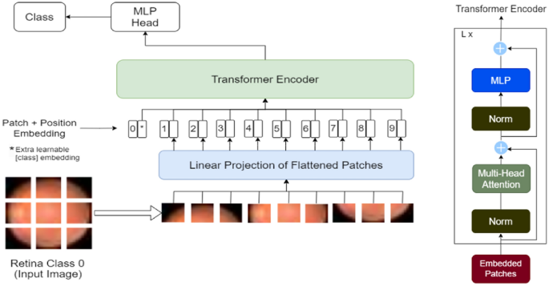
nature.com
Implementing vision transformer for classifying 2D biomedical ...
Suggested filename: fig27-vit-finetuning-pipeline.pdf
Evidence Artefacts for Repository
- vit_inference.py: Script loading model, processing image, generating heatmap.
- Sample outputs: Anonymised images + overlays (from public datasets).
- Configs: config.yaml for model variant, dataset, hyperparameters.
- Explainability module: Separate script using libraries like captum or custom rollout.
This engine demonstrates advanced AI integration while prioritizing explainability—essential for UK healthcare adoption and regulatory review (e.g., MHRA AI as a Medical Device guidance). Include metrics (AUC, sensitivity) from internal validation on public data in docs.

